**Streamlining Object Detection using TensorFlow for Plant Disease Classification.**

Dr. Prathviraj N1 · Sufiya Taranum2 · Sneha V Shet3 · Anushree S G4

# Abstract

Plant diseases pose a significant threat to global agricultural productivity, necessitating timely and accurate detection methods to mitigate crop loss. This project presents a deep learning-based approach to automated plant disease detection using image classification techniques. Leveraging a Convolutional Neural Network (CNN) architecture, the model was trained on a diverse dataset of plant leaf images exhibiting various disease symptoms. Despite achieving high training accuracy, special emphasis was placed on improving the model’s prediction confidence and generalization to unseen data. The system aims to assist farmers and agricultural professionals by providing an efficient, scalable, and non-invasive method for early disease diagnosis. The report details the methodology, dataset preparation, model architecture, training process, evaluation metrics, and potential applications in real-world agricultural scenarios.

# Introduction

Agriculture remains the backbone of the global economy, supplying food, raw materials, and employment to a significant portion of the world’s population. However, plant diseases continue to pose a serious threat to agricultural productivity and food security. These diseases, often caused by pathogens such as fungi, bacteria, and viruses, can lead to substantial crop losses if not detected and treated promptly.

In recent years, advancements in computer vision and deep learning have opened new avenues for the development of intelligent, automated systems for disease detection. Convolutional Neural Networks (CNNs), in particular, have demonstrated remarkable performance in image classification tasks, including the identification of complex visual patterns such as those found in diseased plant leaves. By learning hierarchical representations directly from image data, CNNs eliminate the need for handcrafted feature extraction and offer improved accuracy and scalability.

The ultimate goal of this research is to develop a reliable, scalable, and real-time plant disease detection system that can assist farmers, agronomists, and researchers in early disease diagnosis, thus enabling timely intervention and improving agricultural outcomes.

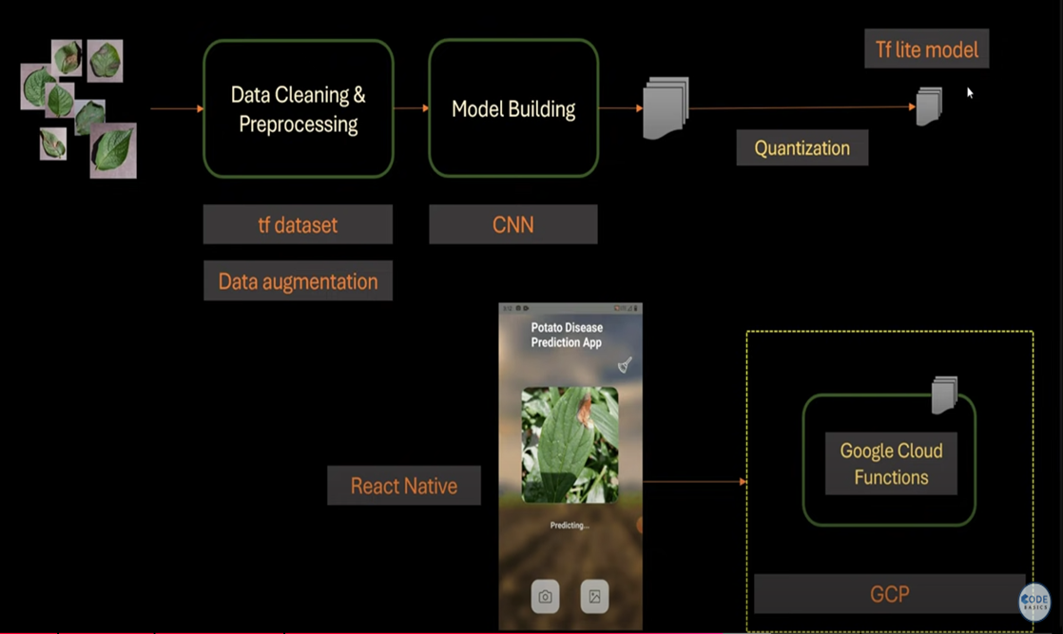

# 2. Literature Survey

Recent advancements in deep learning have led to significant progress in the field of automated disease detection in both agricultural and medical domains. Several studies have leveraged Convolutional Neural Networks (CNNs) to enhance classification accuracy and system efficiency.

[1] Nor Azman Ismail and Ahmed Husham (2022) proposed a hybrid CNN model for the classification of Rumex obtusifolius in grasslands. Their approach focused on improving weed detection and classification accuracy to facilitate efficient grassland management. The integration of hybrid CNN architecture contributed to the automation of weed management processes, highlighting the potential of deep learning in precision agriculture.

[2] S. I. Moazzam, U. S. Khan, and W. S. Qureshi (2023) developed a deep CNN model tailored for multi-class retinal disease detection. This model emphasized minimal memory consumption while maintaining high classification accuracy. The study demonstrated the model's effectiveness in resource-constrained environments, making it suitable for deployment on lightweight devices without compromising diagnostic performance.

# 5. Dataset Preparation

The dataset used in this study consists of 39,152 high-resolution images representing 21 distinct plant disease classes. The data was split into training and testing sets, with 80% of the samples (approximately 31,322 images) allocated for training and the remaining 20% (around 7,830 images) designated for testing purposes. Further, the test portion was equally divided into validation and final test subsets, each comprising 10% of the total dataset (roughly 3,915 images per subset**.**

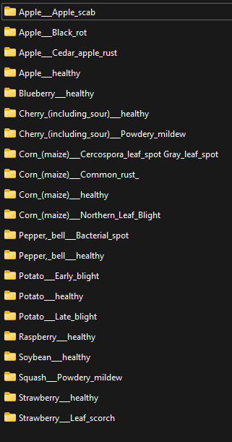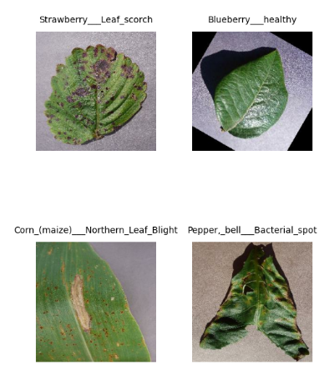

# 6. Data Preprocessing

The data preprocessing phase involved multiple crucial steps to prepare the dataset for efficient model training. All input images were resized to 180×180 pixels to meet the input requirements of the model. Normalization was applied to scale pixel values, ensuring uniform input distribution. Data augmentation techniques such as random rotations, horizontal and vertical flipping, zooming, and brightness adjustments were used to artificially expand the training dataset and introduce variability. These augmentations helped in improving the model’s generalization and minimizing overfitting. Together, data resizing and augmentation significantly enhanced the robustness and accuracy of the plant disease classification model.

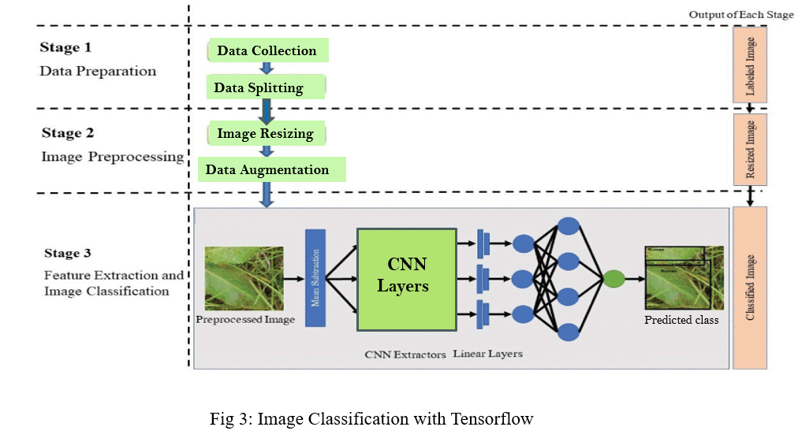

# 7. CNN Architectures and Training

# The plant disease classification architecture consists of an initial convolution layer followed by a max pooling layer and four residual blocks containing convolutional layers with bottleneck design (3×3 convolutions). Each block is stacked in the following pattern: 3, 4, 6, and 3 layers respectively, forming a total of 16 residual units. Batch normalization and ReLU activation functions are used throughout, and global average pooling is applied before the final dense layer. For this project, the top (classification) layer of CNN was replaced with a custom fully connected layer consisting of a dense layer with 512 units and ReLU activation, followed by a dropout layer (to reduce overfitting), and a final dense layer with 21 output units using softmax activation for multi-class classification.

Before being fed into the CNN, the input images underwent a structured preprocessing pipeline. All images were resized to 180×180 pixels to match the model input dimension. Pixel values were normalized using the mean and standard deviation of the ImageNet dataset to align with the pre-trained model’s expectations. Data augmentation techniques such as random rotation, horizontal and vertical flipping, zooming, brightness alteration, and cropping were applied during training to increase the diversity of the dataset. These techniques helped improve generalization, reduced overfitting, and enabled the model to learn invariant features across different leaf shapes, colors, and orientations. This combination of robust preprocessing and a deep CNN architecture enabled accurate and efficient classification of plant diseases across 21 distinct classes.

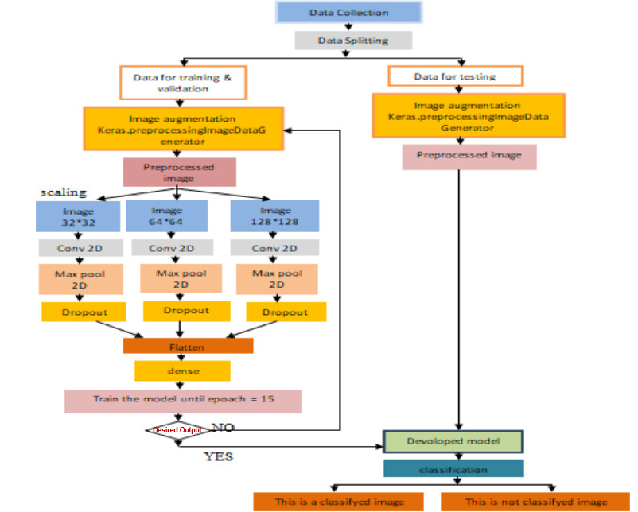

# 8. Experimental Setup

The experimental phase focused on designing, training, and evaluating a deep learning-based model for plant disease classification. Images were resized to 180×180 pixels, normalized, and augmented using techniques such as rotation, flipping, and zooming to enhance generalization and reduce overfitting. The model was trained using a batch size of 32 and evaluated using accuracy and loss metrics. To ensure model robustness and minimize dependency on a single data split, 4-fold cross-validation was implemented. The model was trained and validated across five distinct folds, and performance was averaged to provide a more reliable estimate of generalization ability. Furthermore, probability calibration curves were plotted to assess the confidence of predicted probabilities. The results demonstrate the model’s effectiveness and suitability for real-world agricultural applications.

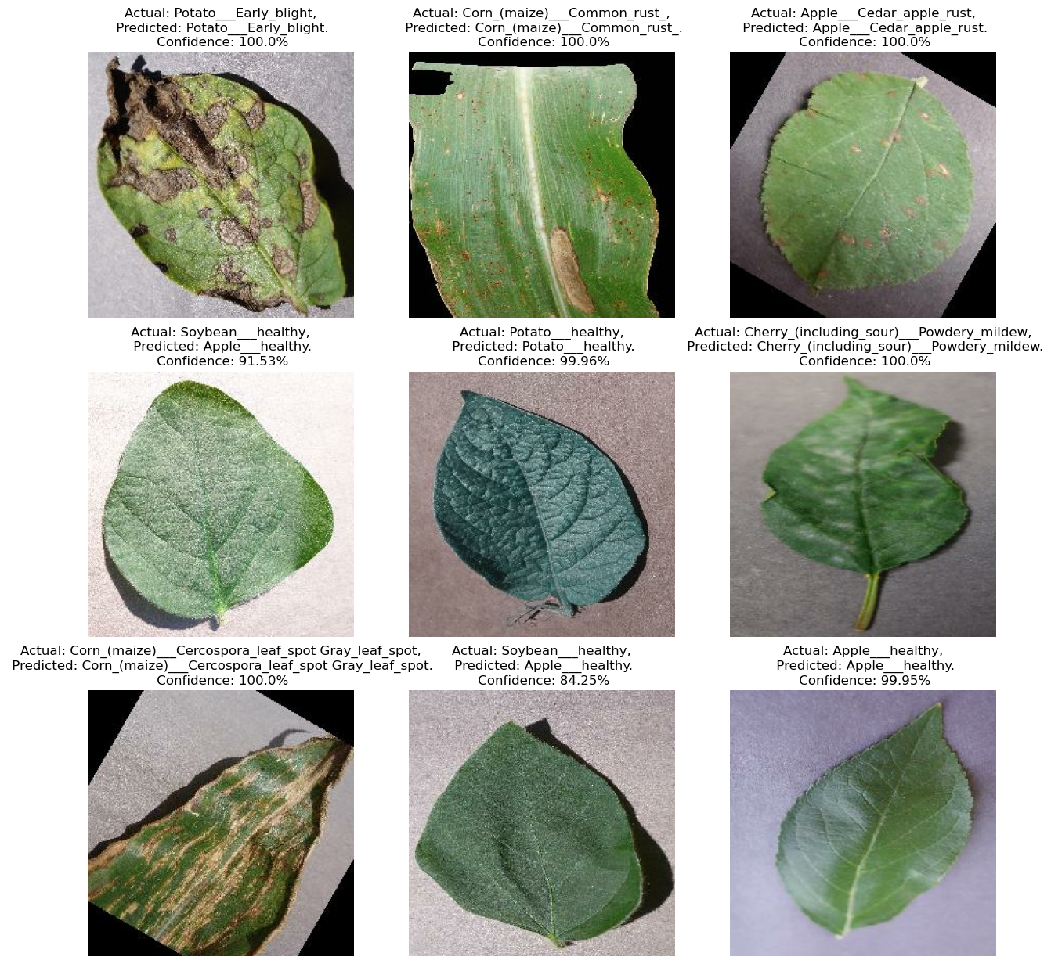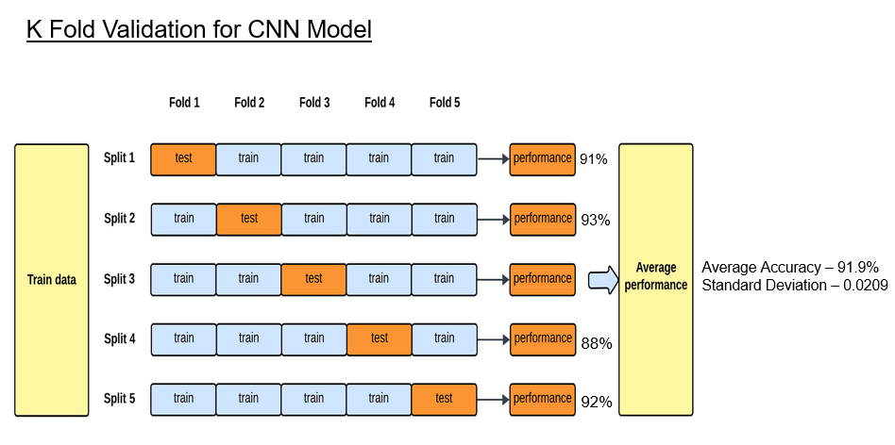

# 9. Results

The performance of the proposed plant disease classification model was rigorously evaluated using 4-fold cross-validation to ensure robustness and reduce bias associated with a single data split. The model demonstrated consistent performance across all folds, achieving an **average accuracy of 91.43%**. The **standard deviation of accuracy was 0.0209**, indicating low variability and stable classification performance across different subsets of the data. The training and validation accuracy and loss were monitored per epoch, showing smooth convergence without significant overfitting. Additionally, probability calibration curves were analyzed to assess the reliability of the softmax outputs, revealing generally well-calibrated predictions. These results affirm the model’s ability to accurately and reliably classify plant diseases across 21 categories using leaf images.

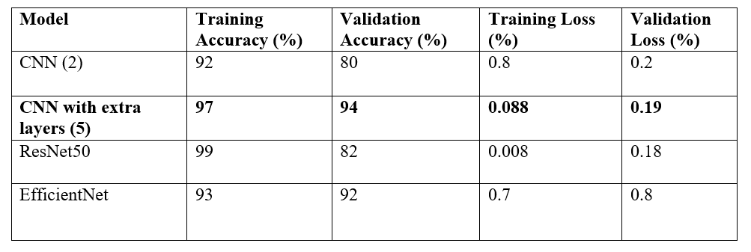

comparisons of different models are shown above in this table.

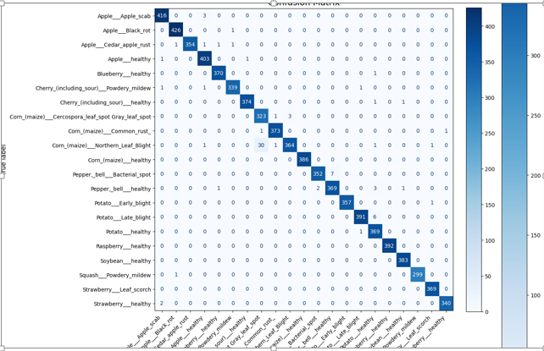

Confusion matrix of the model evaluation is shown above.

For Each class of our project, we have plotted calibration curve as shown below.

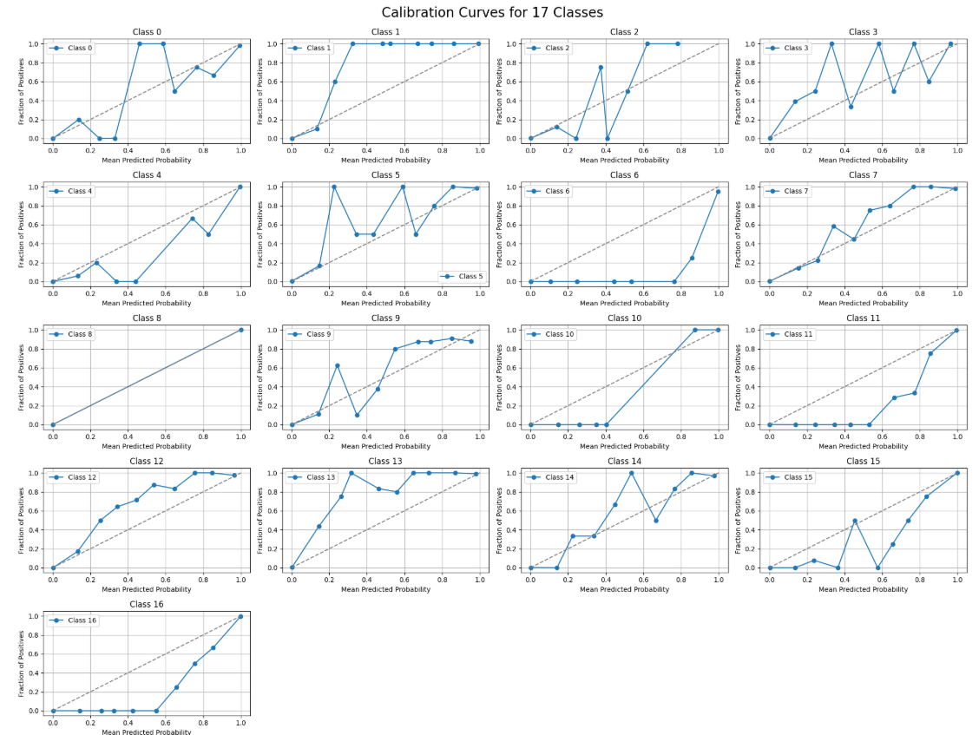

ROC and AUC and Barier curve is as shown below.

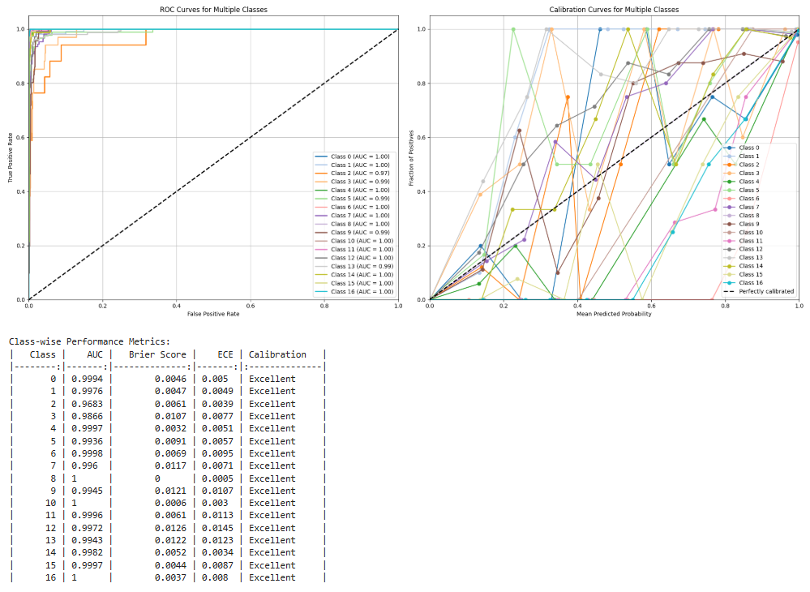

**10. Conclusion and Future Work**

This study presents a deep learning-based framework for the automatic detection and classification of plant diseases using image data. By employing Convolutional Neural Network, the model achieved high training accuracy on a large dataset comprising multiple plant species and disease categories. Data augmentation techniques were integrated to enhance generalization, while standard performance metrics were used to evaluate classification robustness. Although the model performed well in terms of accuracy, the inference results revealed low softmax confidence scores, suggesting the presence of overfitting or class imbalance in the dataset. Despite these challenges, the proposed system demonstrates significant potential as an effective tool for early disease detection, offering scalability, automation, and real-time diagnostic support for agricultural applications.

# References

[1] Hybrid CNN Model for Classification of *Rumex obtusifolius* in Grassland

* Authors: Ahmed Husham Al-Badri, Nor Azman Ismail, et al.
* Published in *IEEE Access*, 2022

[2] Multi-Class Retinal Diseases Detection Using Deep CNN with Minimal Memory Consumption

* Authors: Nawaz, Asif; Ali, Tariq; Mustafa, Ghulam; Babar, Muhammad; Qureshi, Basit
* Published in *IEEE Access*, 2023

[1] C. Huyen, [Introduction to Machine Learning Interviews](https://huyenchip.com/ml-interviews-book/)(2021), Self-published

[2] V. Tuulos, [Effective Data Science Infrastructure](https://www.manning.com/books/effective-data-science-infrastructure) (2022), Manning Publications Co.

<https://towardsdatascience.com/streamlining-object-detection-with-metaflow-aws-and-weights-biases-b44a14cb2e11>

<https://github.com/EdIzaguirre/plant-object-detection>

<https://www.tensorflow.org/tutorials/images/classification>